**Ex.No 16**

**REPEAT LOOP AND WHILE LOOP IN PL/SQL**

1.Write a PL?SQL program to print “hello”

Ans)

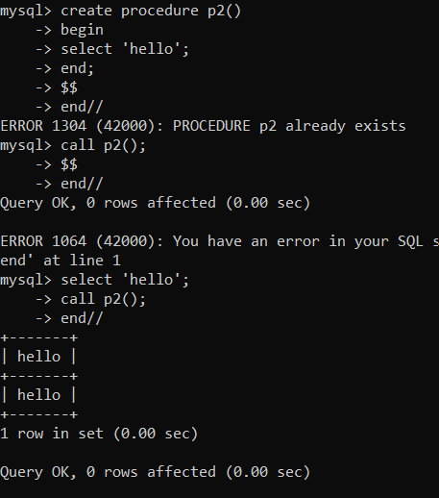

2.Write a PL/SQL repeat loop to print numbers from 1 to 10

Ans)

